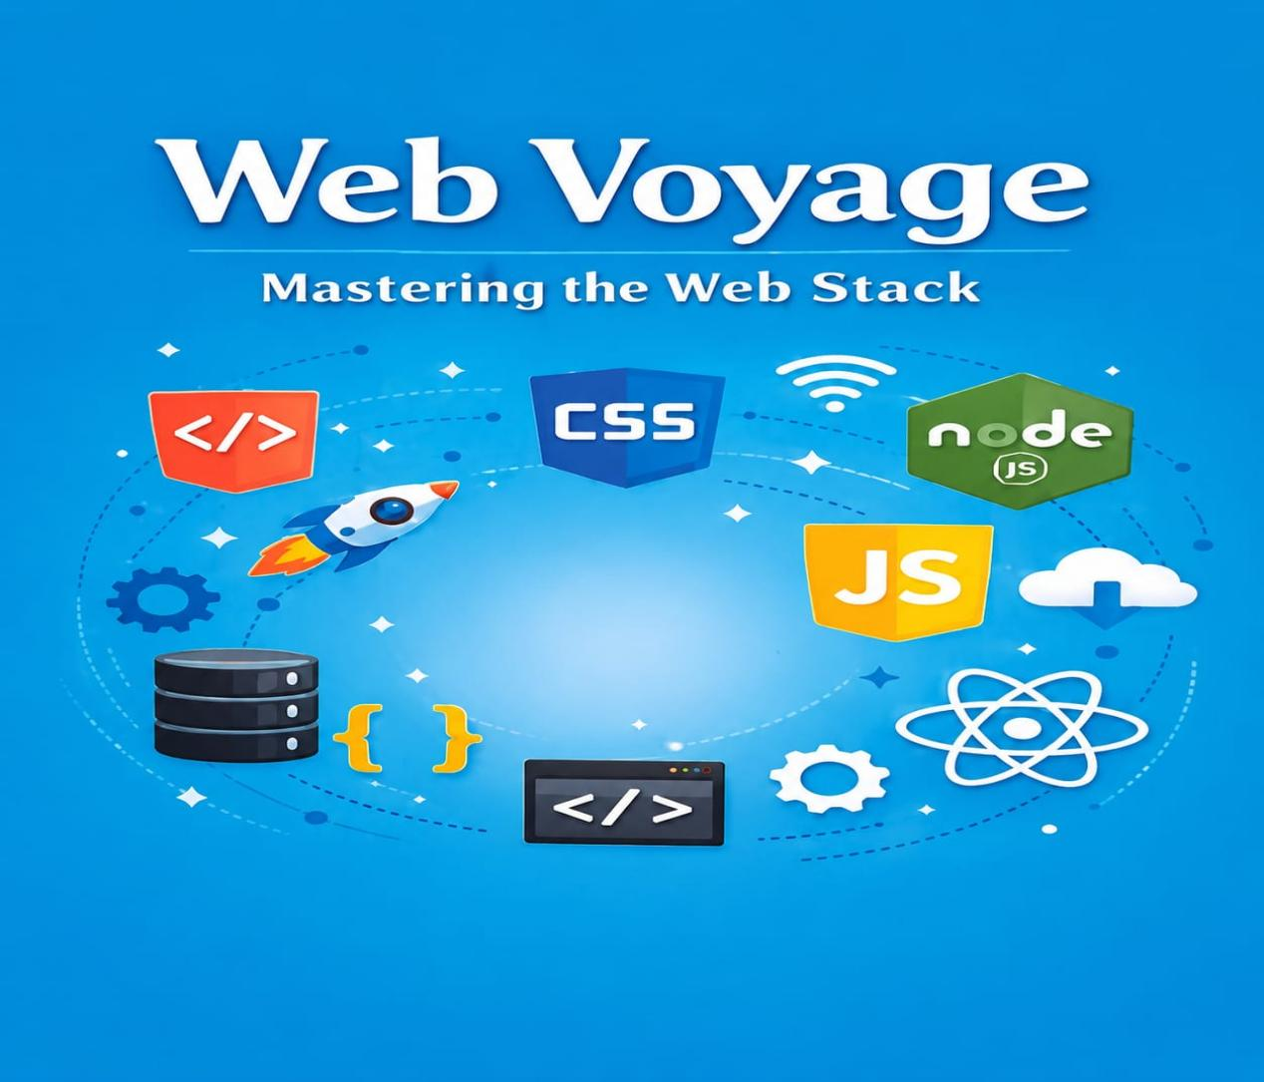

①Html ②CSS
③JavaScript ④React.js
⑤Bootstrap ⑥Node.js
⑦php ⑧Git & GitHub

By Jawad Jammoul

